Updated 2026-02-09
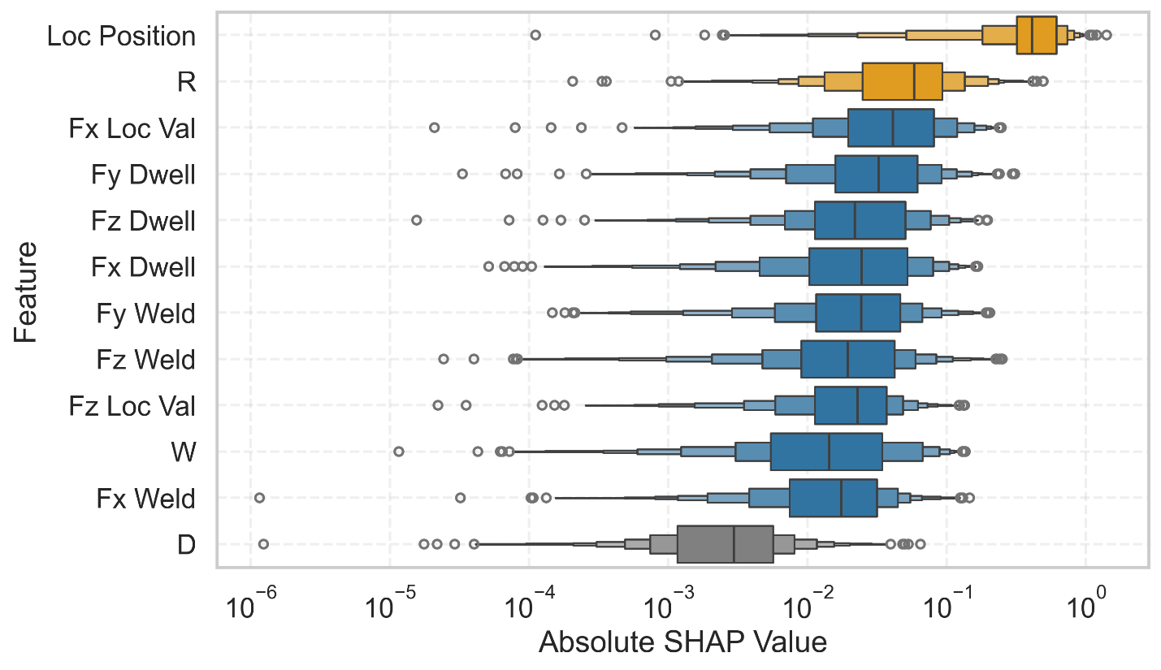
The graph presents the SHAP values corresponding to the different input features, illustrating their relative contributions to the prediction of residual stress.
- Position exhibits the highest SHAP values, indicating the strongest correlation with the residual stress along the center weld line.
- Rotational speed ranks second in importance. The remaining features—those derived from Fx, Fy, Fz, and welding speed—have a moderately lower influence compared to rotational speed and position.
- Dwell time shows the least impact on residual stress.
- The features derived from the forces during the dwell stage exhibit greater significance than the dwell time parameter itself.

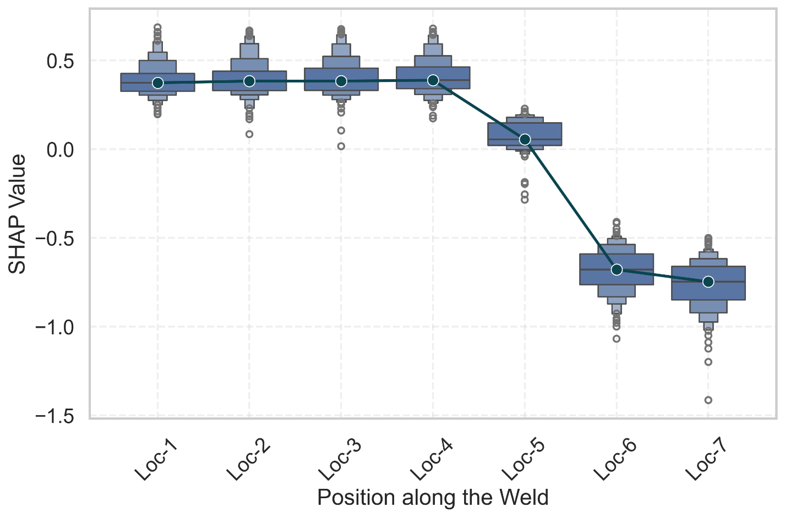
The following figure illustrates the SHAP values of position in relation to the corresponding position index.
- A clear trend can be observed between the SHAP value and the location index.
- For the first four positions, the SHAP values indicate a positive contribution, whereas the last three positions exhibit a negative contribution.
- This pattern suggests that the residual stress tends to be more tensile in the initial section and becomes more compressive toward the later positions.
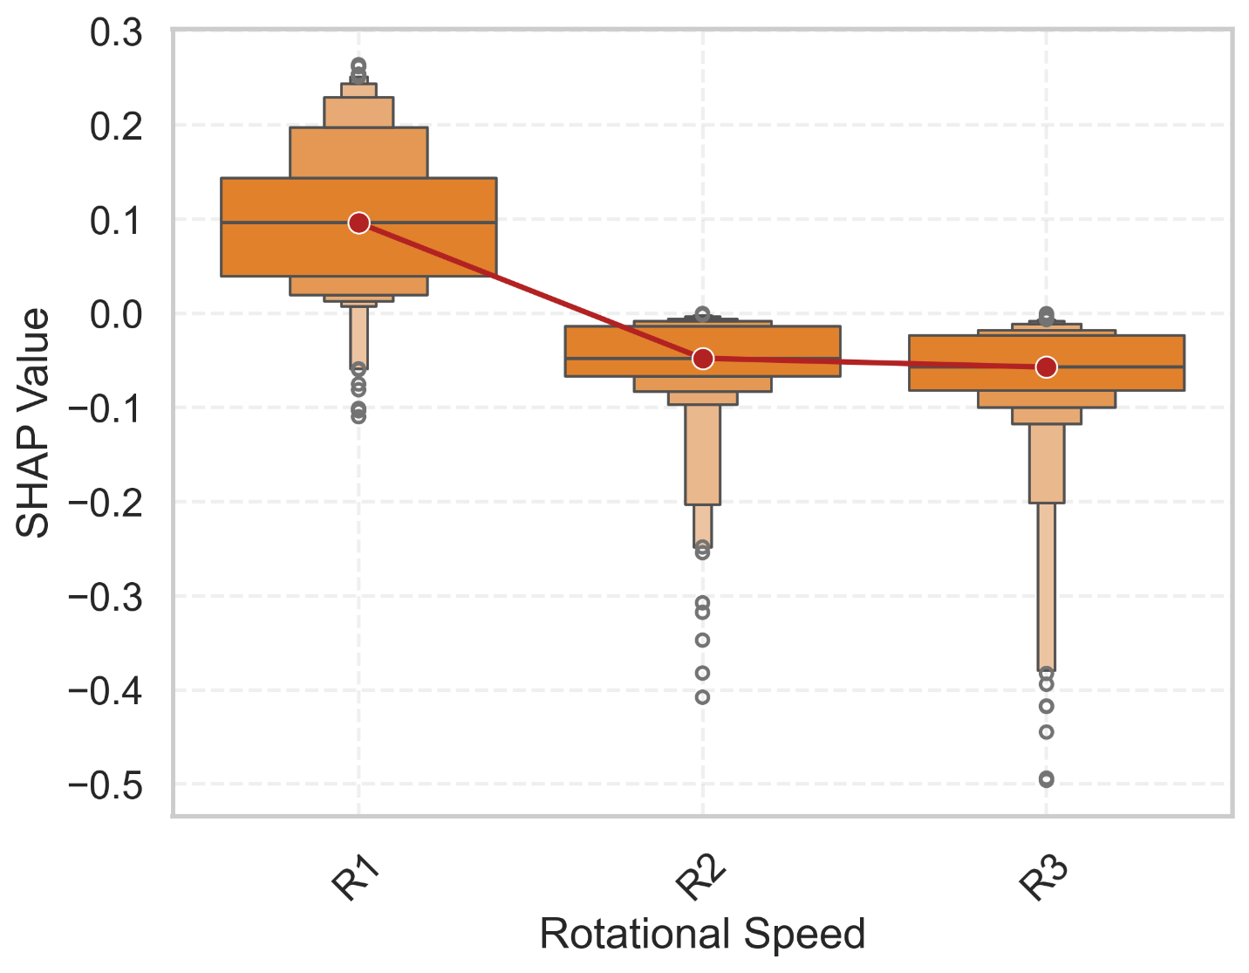
- The next figure presents the SHAP values for rotational speed, revealing an inverse relationship between rotational speed and residual stress. This indicates that as the rotational speed increases, the residual stress tends to become more compressive.
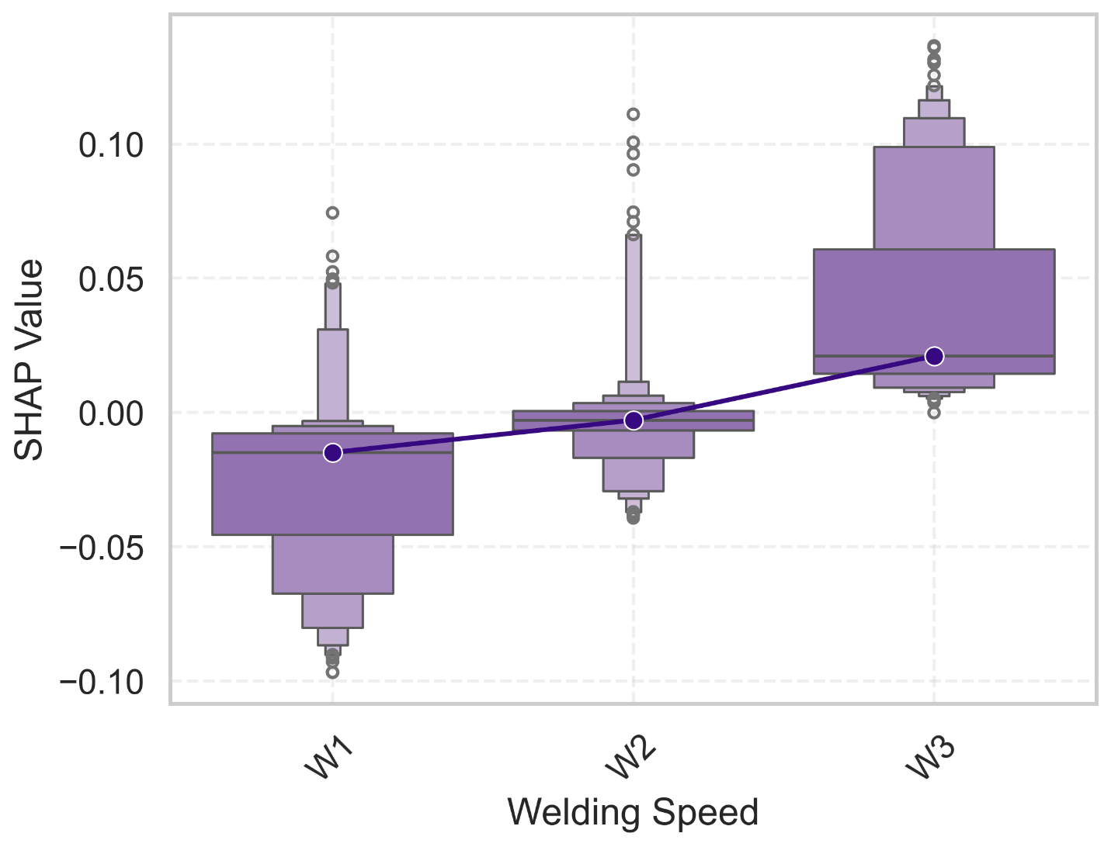
- In contrast, welding speed exhibits an opposite trend, where an increase in welding speed contributes to a higher tensile residual stress.
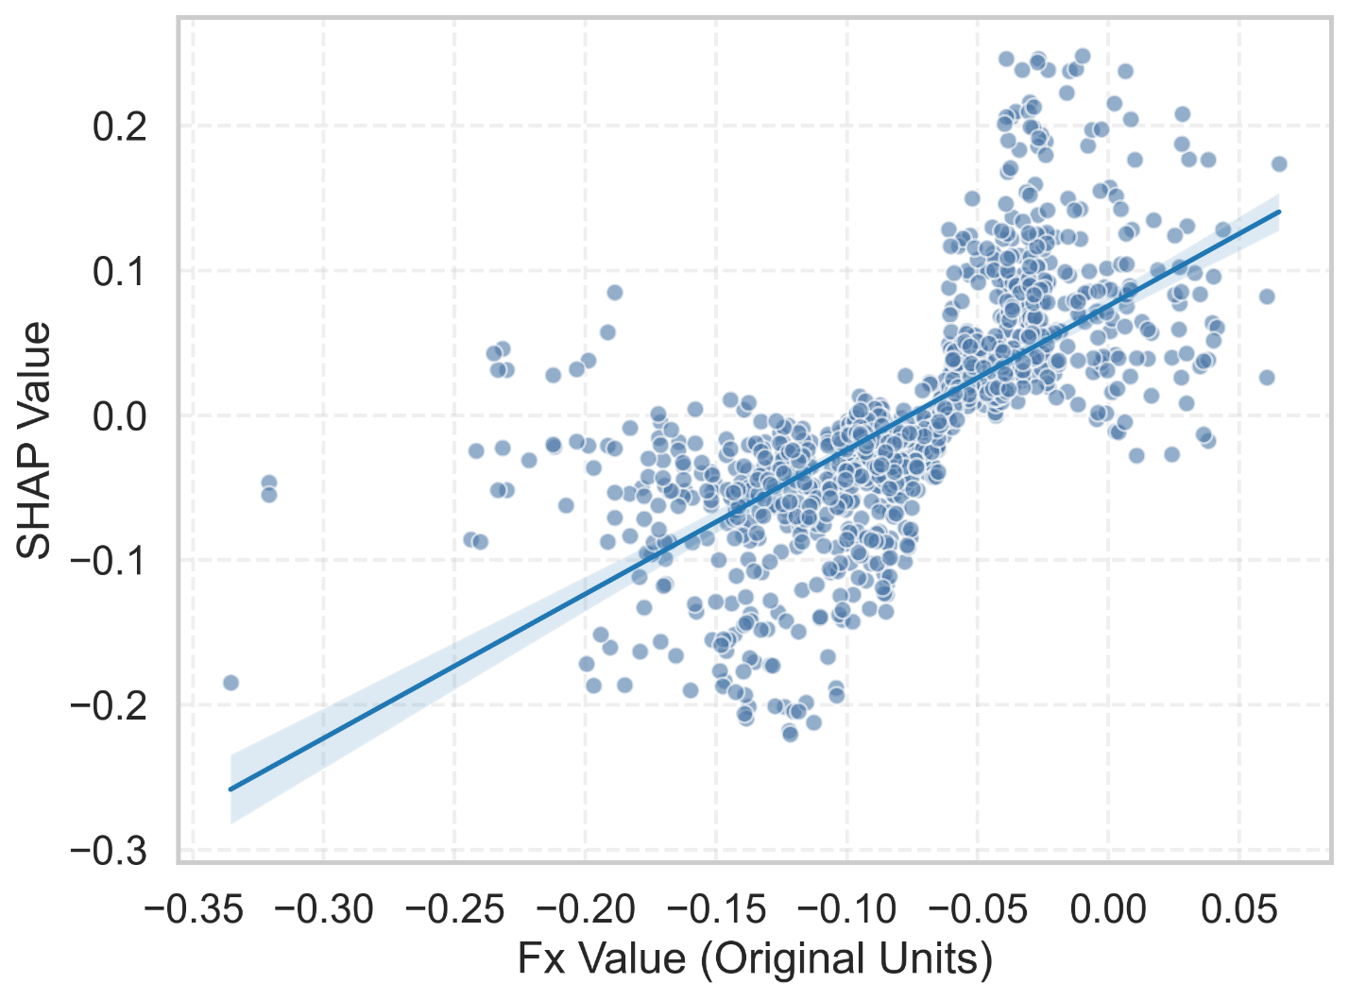
The plot of SHAP values against Fx reveals a positional correlation, indicating that the force in the x-direction varies systematically with the weld position.
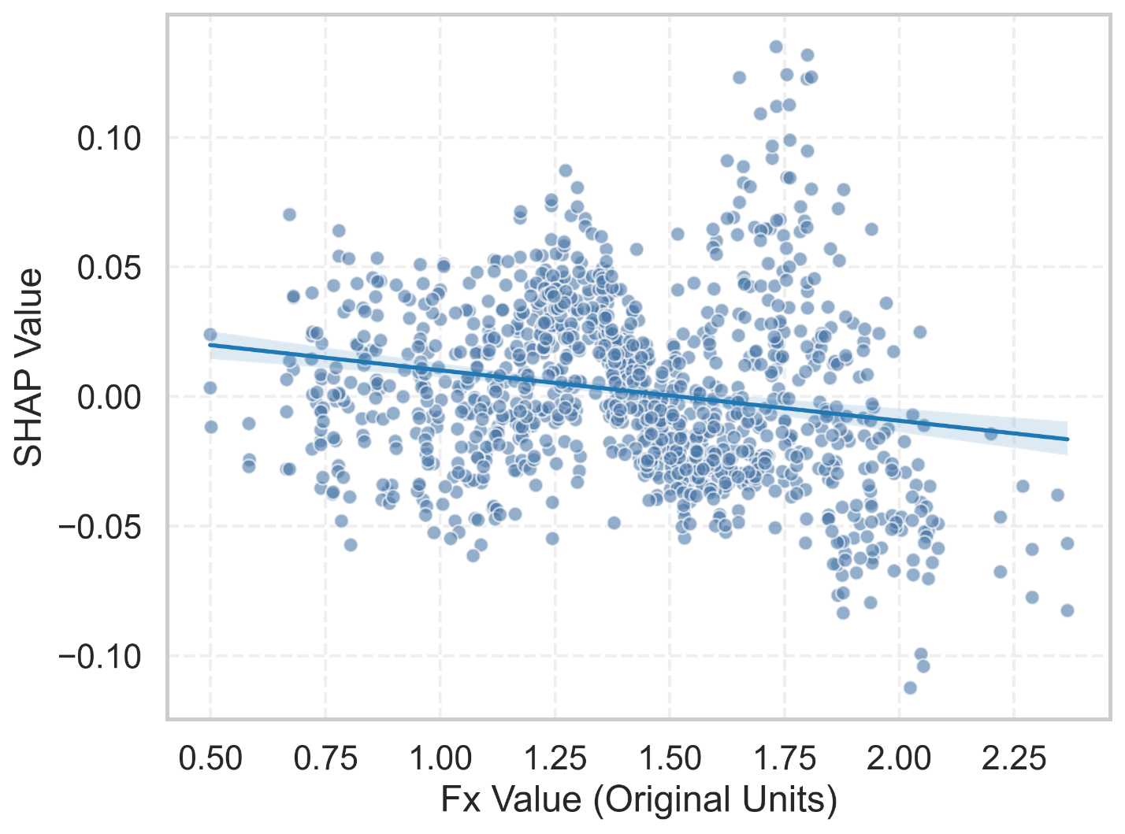
The SHAP values of Fz indicate that as Fz increases, the residual stress tends to become more compressive. However, this trend is relatively weak compared with the influence observed for Fx.

